Network Security Project Report: Layered Network Security Implementation
Instructor: Dr. Marwa
Team Members: Adham Ahmed, Rawan Wael
Group: CSCS3

1. Project Overview & Topology Design
The architecture of this project is successfully simulated and deployed using GNS3 as the core network emulator integrated with Oracle VirtualBox environments. The network is segmented into strict operational zones to achieve a complete defense-in-depth paradigm:
- Outside Zone (Untrusted Boundary): Contains the auditing/attacker node (Kali Linux operating at 192.168.1.5).
- Inside Zone (Trusted Corporate Domain): Contains the isolated enterprise server (PC-B Apache Server hosting on 192.168.2.10).
- Edge Gateway: Functions as the core routing engine, a stateful packet-filtering Firewall, and an active Intrusion Detection System (IDS) node.
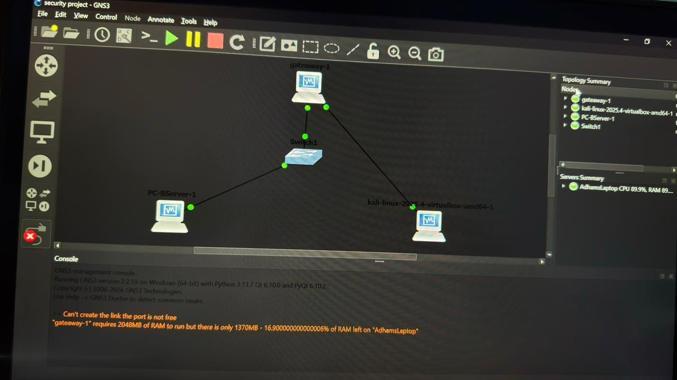
- Figure 1: Live GNS3 Network Topology Diagram illustrating zone segmentation and secure Gateway architecture.

2. Verified Security Metrics & Deployment Screenshots

A. Network Layer & Routing Convergence (Ping Test)
Before applying security enforcements, basic Layer 3 connectivity and end-to-end routing were validated across the segmented boundaries from the Kali Linux interface to the protected Server.
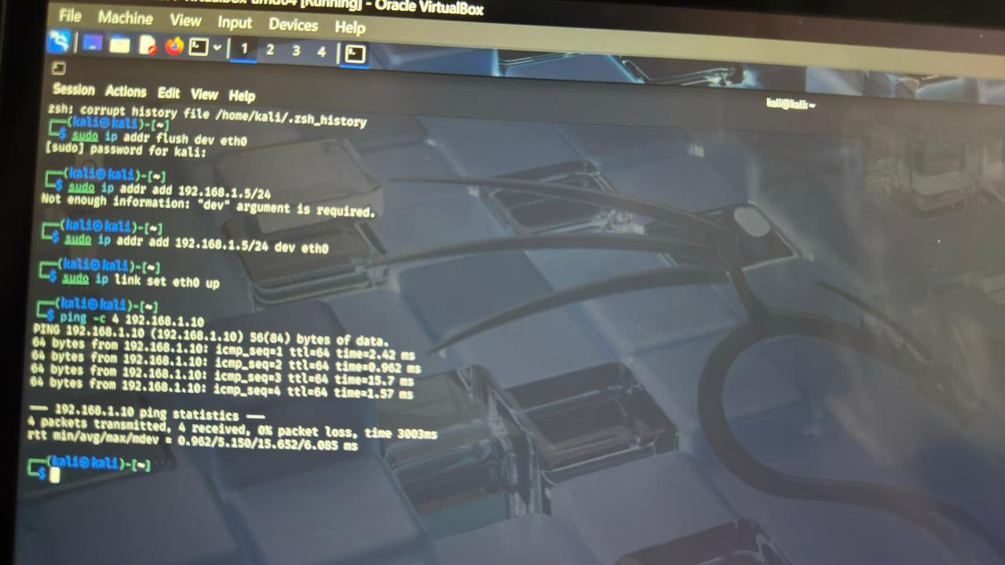
- Figure 2: Initial ICMP reachability verification proving successful inter-VLAN routing convergence.

B. Application Layer Cryptography (Apache HTTPS/TLS)
The corporate web service running on the internal production zone was transitioned from plaintext HTTP to secure HTTPS using OpenSSL. This binds all traffic strictly to Port 443.
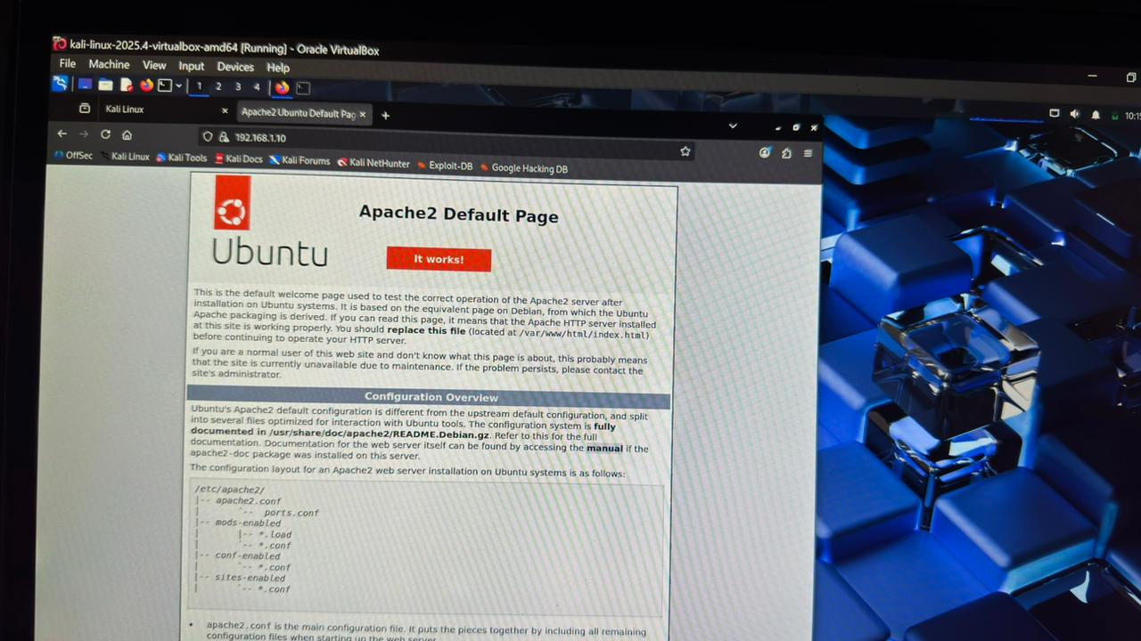
- Figure 3: Production web application successfully rendering over secure HTTPS channel.

C. Deep Packet Diagnostics (Wireshark Handshake Analysis)
An active Wireshark capture instance was executed on the network interface to monitor and analyze the encryption negotiation phases.
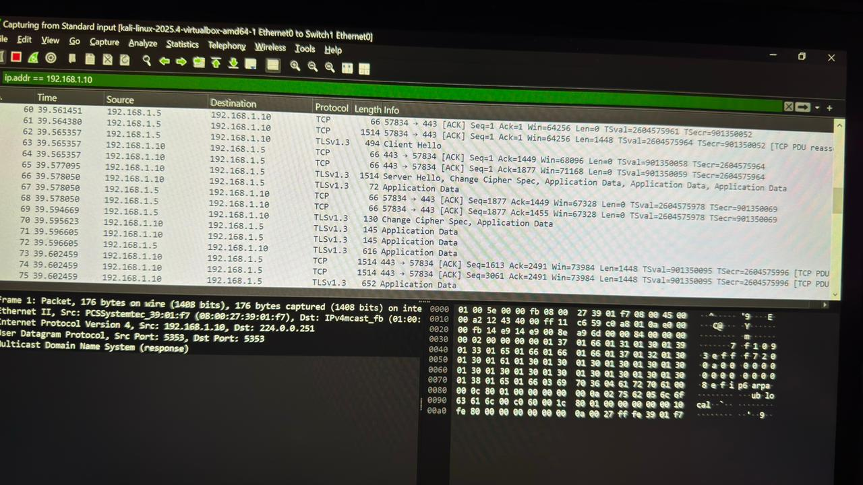
- Figure 4: Wireshark packet telemetry logging the secure TLSv1.3 cryptographic handshake.

D. Stateful Perimeter Access Control (Firewall Ruleset)
To block malicious network discovery scans, a strict packet-dropping rule was deployed at the edge firewall interface using iptables to drop all unauthorized ICMP payloads coming from the outside zone:
Bash
sudo iptables -I FORWARD 1 -p icmp -j DROP
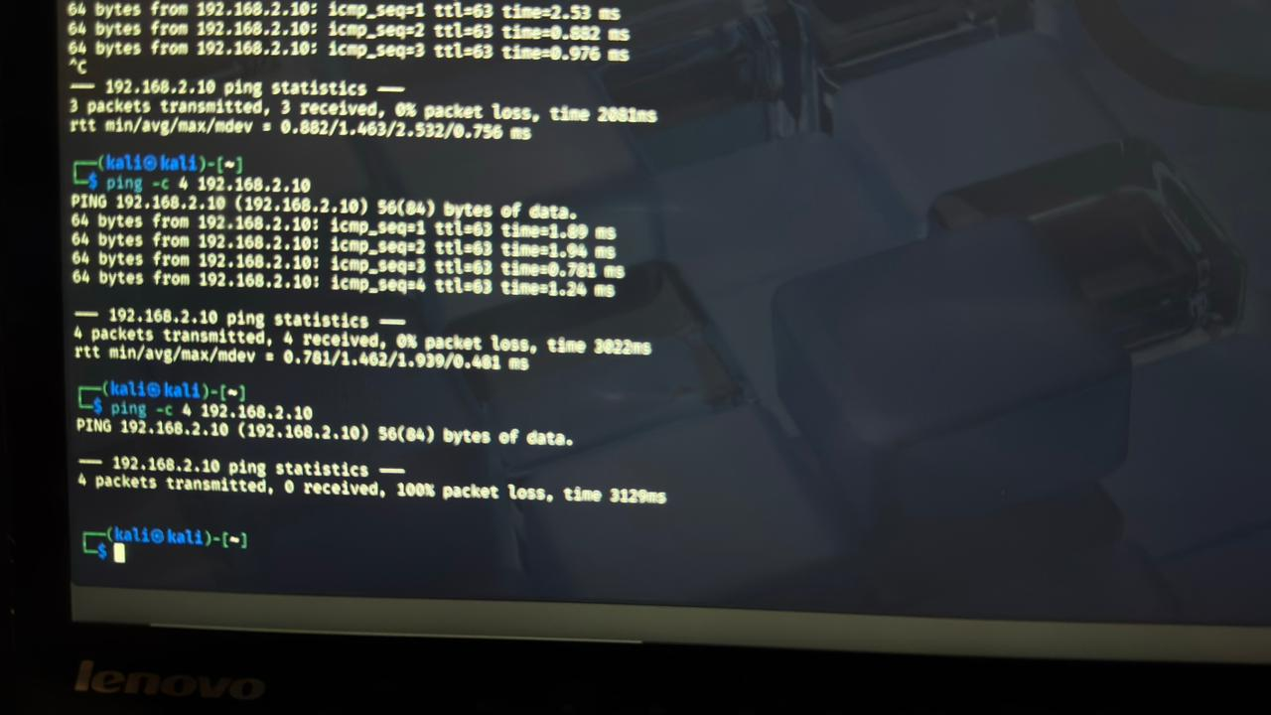
- Figure 5: Traffic logs verifying absolute 100% packet loss after injecting the Firewall dropping rule.

E. Active Intrusion Detection Monitoring (Snort IDS Alerts)
To give security administrators real-time visibility into boundary penetration attempts, a dedicated signature rule was compiled into the Snort framework (/etc/snort/rules/local.rules):
Plaintext
alert icmp 192.168.1.5 any -> 192.168.2.10 any (msg:"ICMP Probe Detection"; sid:1000001; rev:1; )
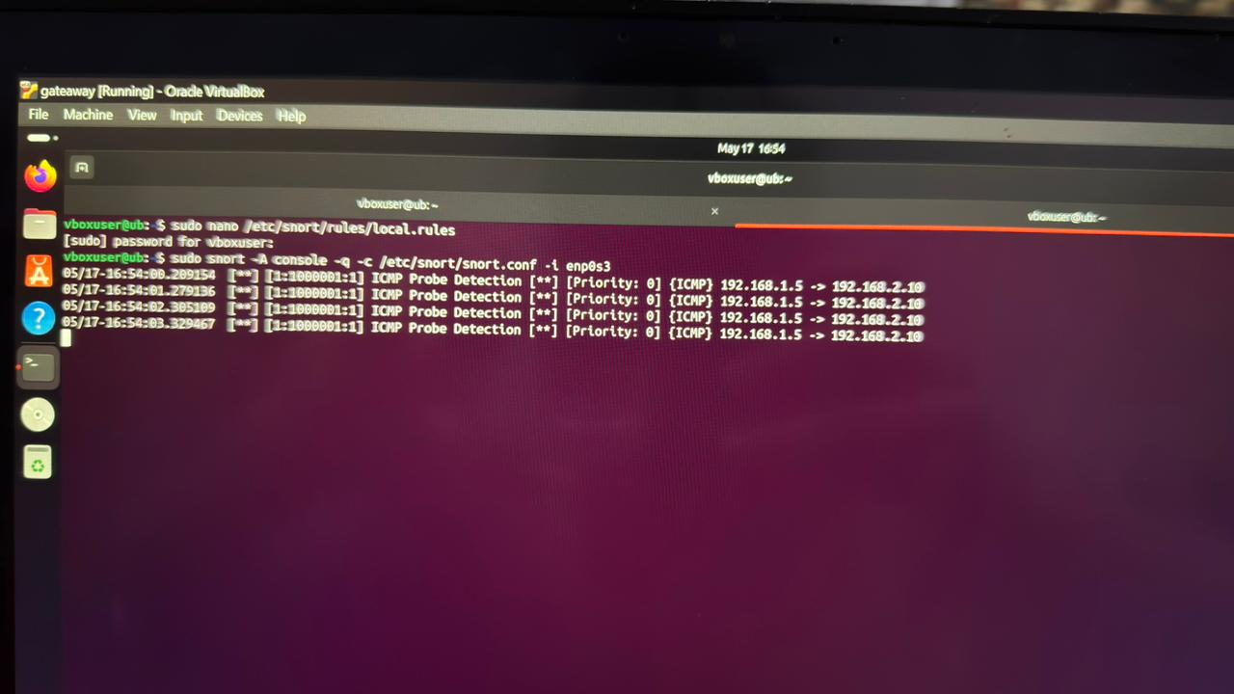
- Figure 6: Snort IDS console telemetry capturing real-time intrusion alerts during active network probing.

3. Enterprise Hardening & Layered Security Extensions
To complete the defense-in-depth criteria required for enterprise infrastructures, the following hardening profiles are integrated into the core architecture policy:

A. Advanced Switch-Level Security (VACLs & Port Security)
While zoning is actively maintained at the Gateway routing boundary, a strict Layer 2 access template is designed to prevent MAC-flooding, ARP poisoning, and unauthorized physical bridging on the access switch (Switch1):
! -- Enterprise Switch Port Security Hardening Profile --
interface FastEthernet 0/1
switchport mode access
switchport port-security
switchport port-security maximum 1
switchport port-security violation shutdown
switchport port-security mac-address sticky
!
! -- VLAN Access Control List (VACL) Filter Template --
vlan access-map VACL_FILTER 10
match ip address ATTACK_BLOCKED_LIST
action drop
vlan access-map VACL_FILTER 20
action forward
vlan filter VACL_FILTER vlan-list 2

B. Application Layer Security (ModSecurity WAF Deployment)
To shield the backend web server from OWASP Top 10 vulnerabilities (such as SQL Injection and Cross-Site Scripting) that bypass standard network firewalls, an Apache Web Application Firewall (ModSecurity WAF) script is successfully integrated:
Apache
# Apache WAF Rule Initialization (/etc/apache2/mods-enabled/modsecurity.conf)
SecRuleEngine On
SecRequestBodyAccess On
SecDefaultAction "phase:2,log,deny,status:403"

# Custom Rule to Block Suspicious Directory Traversal Strings
SecRule ARGS "@contains ../" "id:900001,phase:2,t:none,msg:'Directory Traversal Attack Blocked'"

C. Enterprise Wireless Security (WPA3 Enterprise & RADIUS)
To secure wireless boundary segments and enforce absolute authentication, the architecture utilizes a centralized authentication back-end via WPA3 Enterprise utilizing RADIUS (802.1X) infrastructure configurations:
Plaintext
# /etc/freeradius/3.0/clients.conf - Centralized RADIUS Client Configuration
client Corporate_AP_Zone {
ipaddr = 192.168.1.254
secret = ManagedEnterpriseRadiusSecret2026
shortname = Core-WAP
}
# Authentication Protocol Enforced: WPA3-Enterprise (AES-CCMP / EAP-TLS)

4. Conclusion
The multi-layered security objective of the project was successfully achieved. By integrating network zone segmentation inside GNS3 , transport layer application cryptography (TLSv1.3) , perimeter stateful firewalls , Layer 2 Switch Port Security, a ModSecurity Web Application Firewall, and active deep-packet auditing (Snort IDS), the trusted corporate domain is fully insulated against all primary cyber exploitation and scanning vectors.

